

Software Engineering 4 year

Ajax&json&xml

Lecture: Earl Gaylard

Student: Lyu Zheng A00248564

Subject:CLIENT-SIDE TECHNOLOGIES

Assignment report

Introduction:

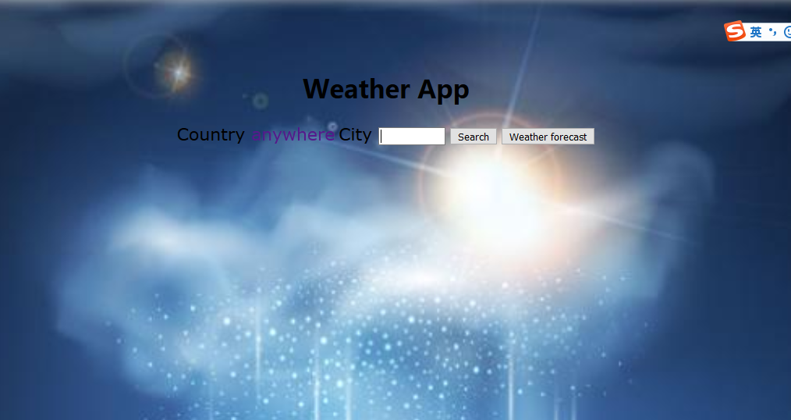

This is the generally interface. If you input a city name, the interface will show the chart of temperature in the next 24 hours:

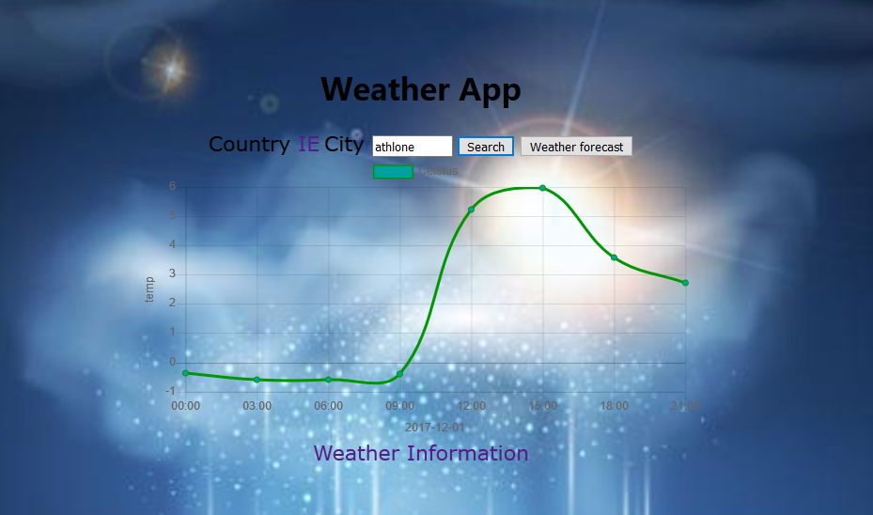

Then click the “Weather Information”, you can see the other details of weather at that time. Click the ”Temperature Information” to go back to the temperature line chart.

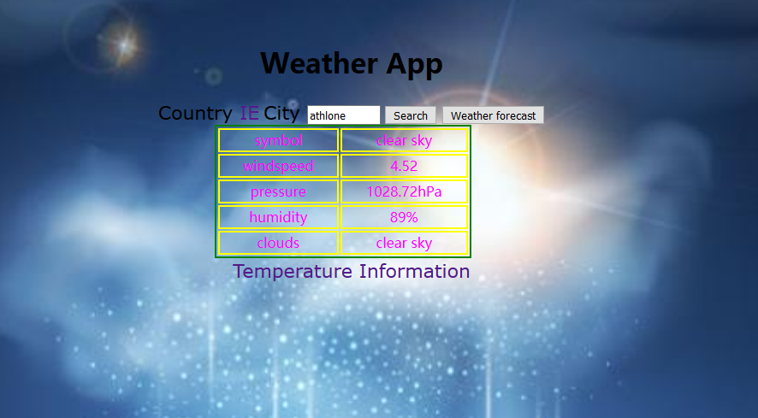

And when click the weather forecast, you can see the weather icon of next 24 hours.

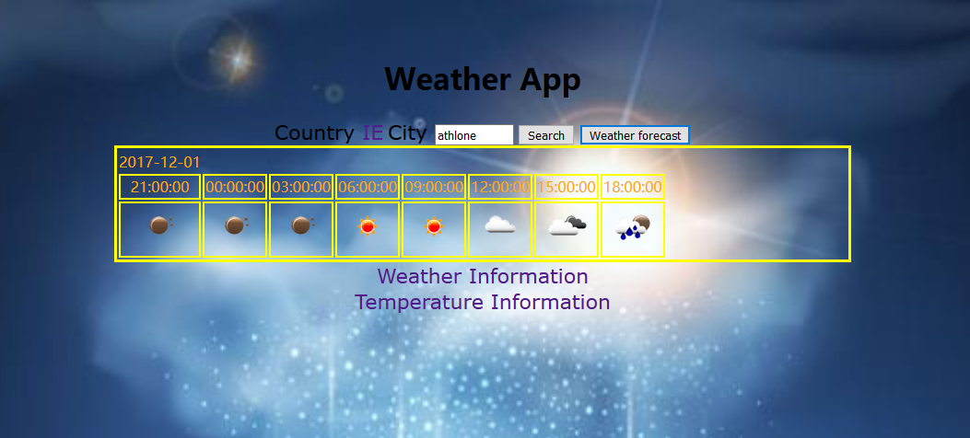

Code:

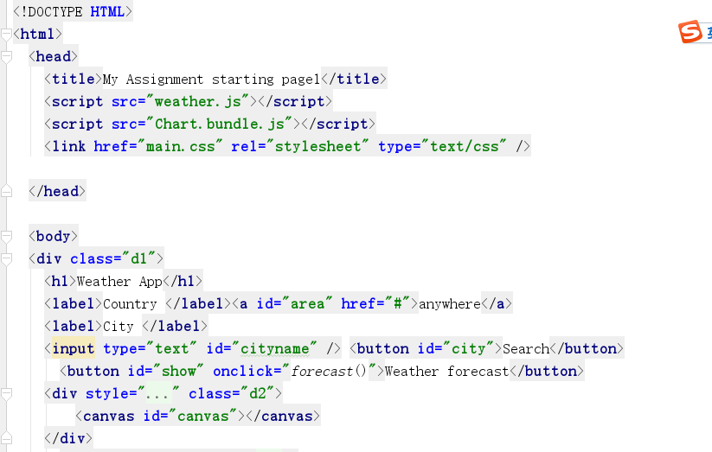

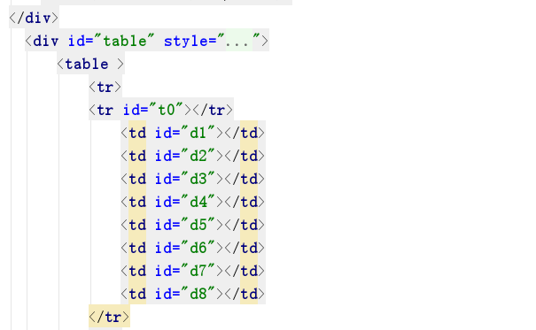

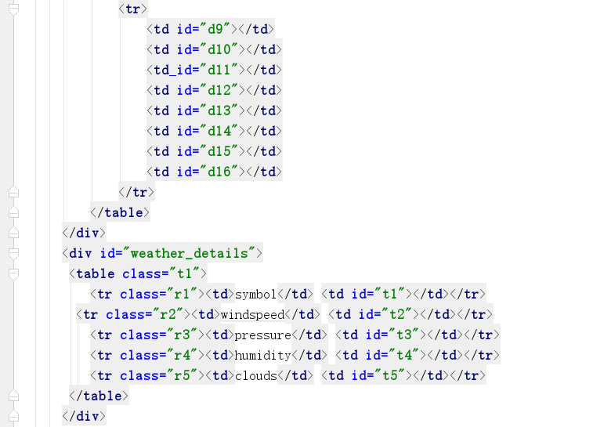

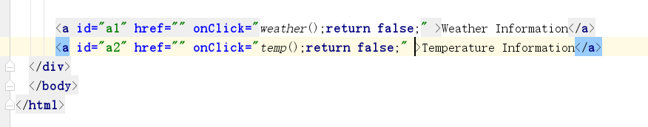

Those are generally interface. Now here is about javascript.

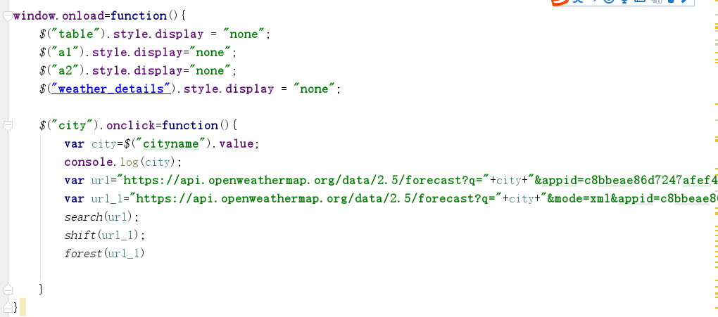

At first we will not show the tables and any data. If we input a city and click the button “search”,

We can send 2 urls to some functions.

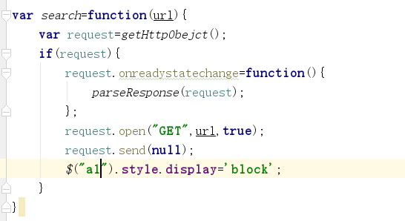

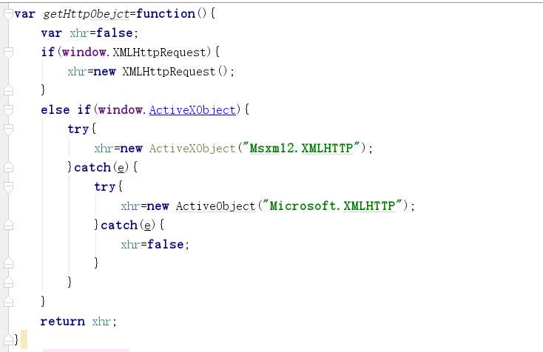

At first we should require for httpObject, the getHttpObject() function is to do that. Than create request as a httpObject .

Than we listen to the response. If the readyState equals 4(means ready) and the status equals 200&304(means server get the request and runs well), we can do the next to get the data. Or we will get a warn message.

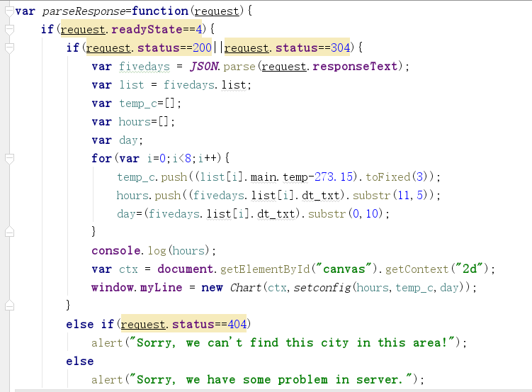

These are the main way to get the json data. Get the response data, change it to json type, and I create a “fivedays” to get all the data, create some arrays to get the list I want, like temperature and hours. There are eight time area in one days’ data, so I loop for eight times to get the data. Then the create a object to make the chart.

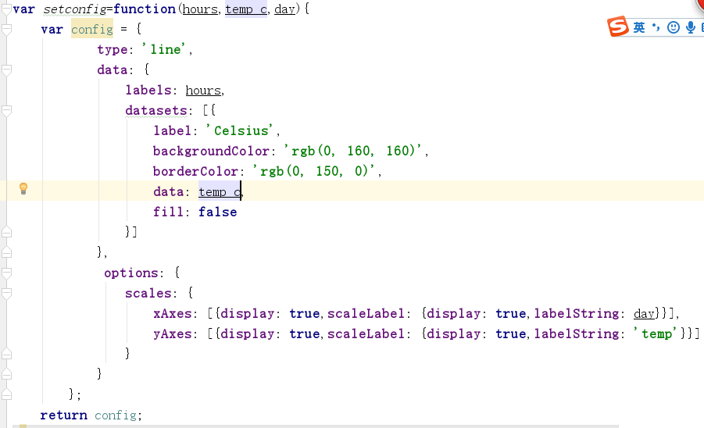

This is the function to make a line chart, there are three attributes for it:hours is the data for x area, temp c is the data for y area and day is to show the date under the chart.I just put the data in the function and get the chart.

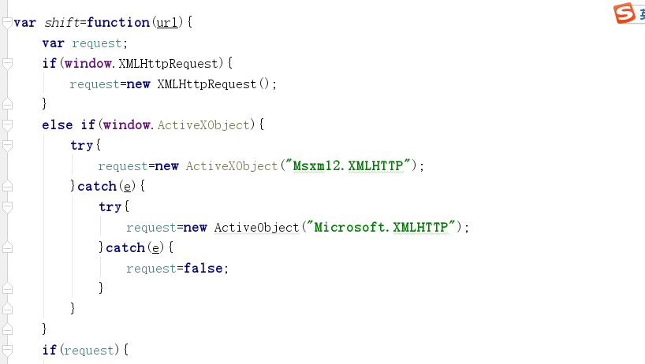

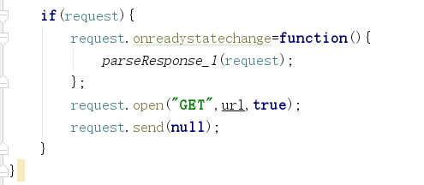

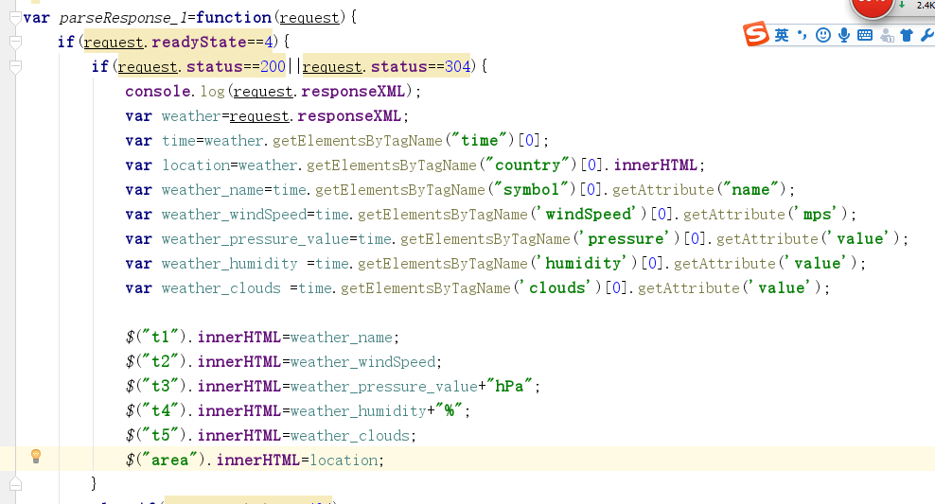

The shift function is about the shift between temperature and weather information. It is worth to mention the weather data is the type of XML. I use getElementsByTagName to get the elements and getAttribute to get data. Than put the data into the table.

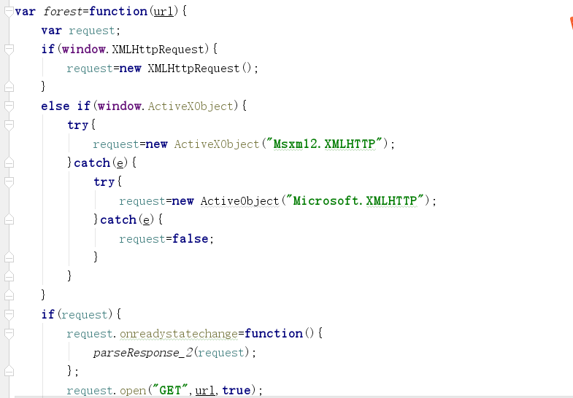

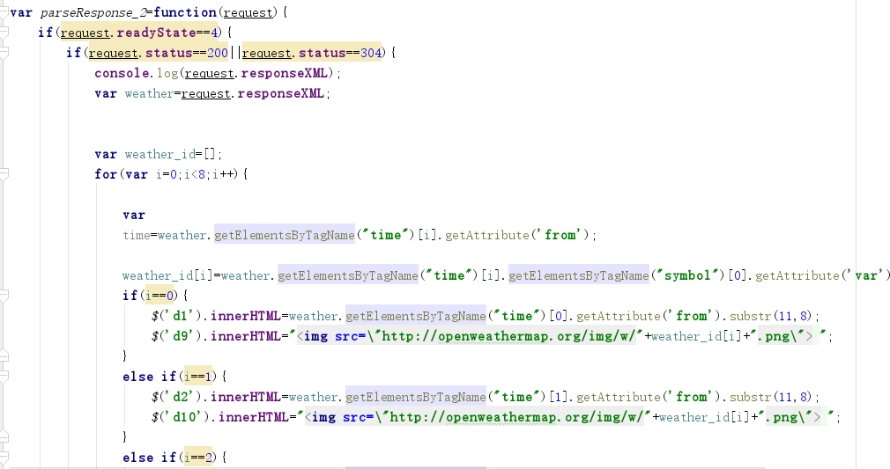

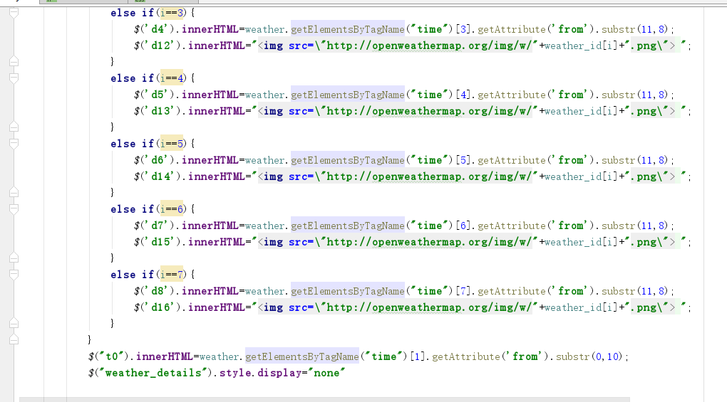

The forest function is about weather forecast.The data is also XML type and I get weather icon for each time area by the same way of weather details.

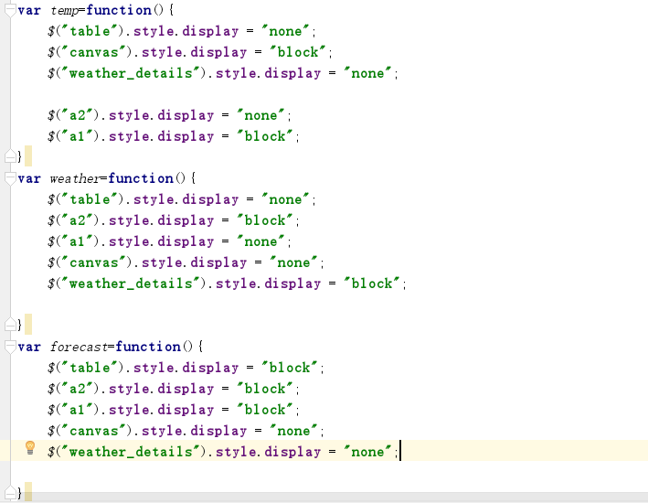

These are some functions of the interface at first.

This is for css:

